BA NA HILLS, DA NANG, VIET NAM

2D1N

OVERVIEW

## location

Ba Na - Chua Mountain tourist area belongs to Hoa Vang, Da Nang, it is far about 50 meters from the central city to the west. Located on the high of 1.487 meters above sea level, the temperature of this place is cool, the average temperature in the summer is about 180C, Ba Na - Chua Mountain is an ideal eco - tourism in the Central Vietnam.

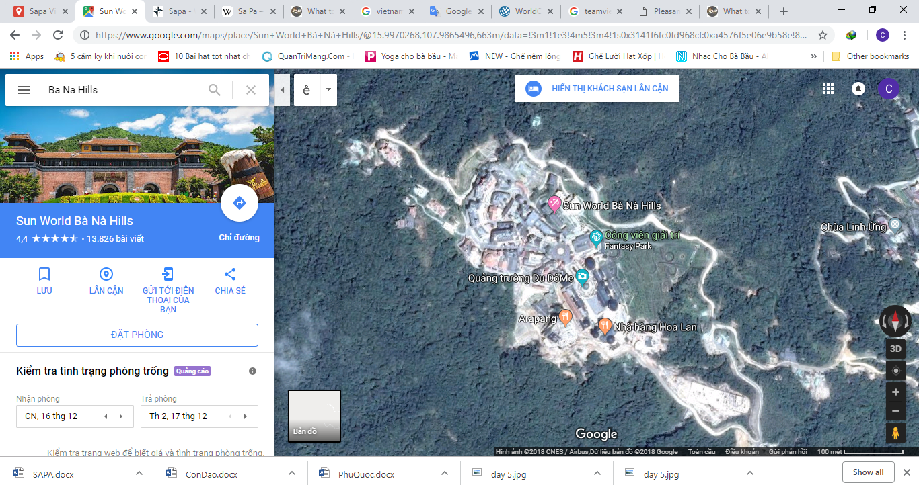

## Characteristics

Ba Na has various flora and fauna. In the old-growth forest, there includes 256 species of fauna, 61 species of animal, 178 species of birds and 17 species of reptile. The flora includes 543 species. Besides, Ba Na has many rare animals such as: Crested Argus, Asian Black Bear, northern buffed-cheeked gibbon…

In 1986, Ba Na was recognized as natural reserve area, in which tropical forest and rare animals are protected. At the beginning of the 20th century, in order to serve the French’s vacation in the Central Vietnam, many hotels, villas were built along mountain side, Nui Mountain and Ba Na hill. After the war, this place was destroyed. Da Nang has recently restored and remodeled some ancient French villas, Buddhistical cultural area, hotels, bars…

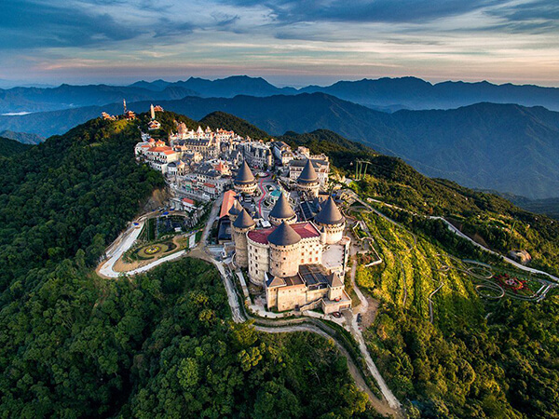

|  |  |
| --- | --- |
|  | Saigon – Ba Na Hills |

## how to get to sapa

* By plane:

From Tan Son Nhat International Aiport in Saigon for transits to Da Nang with Da Nang International Airport



* **Son Tra Peninsula**

Considered as a hidden jewel of Da Nang, Son Tra Peninsula is definitely the place that you cannot miss. This Peninsula provides beautiful landscapes with different kinds of plants and animals. Its natural environment is an ideal destination a picnic or an adventurous journey through the pristine jungle.

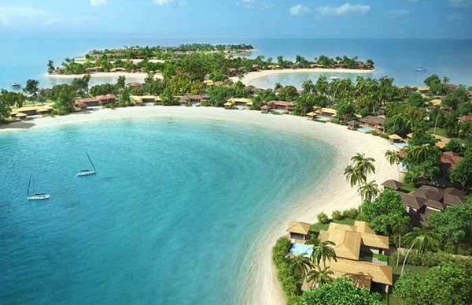

* **Marble Mountain (Ngu Hanh Son)**

The Marble Mountain is a cluster of five hills, which are named after the 5 elements: Metal, Wood, Water, Fire, and Earth. A visit will bring you an adventure to explore the caves and temples in inside. Visitors can buy marble-made souvenirs like bracelets and necklaces at the bottom of the mountain.

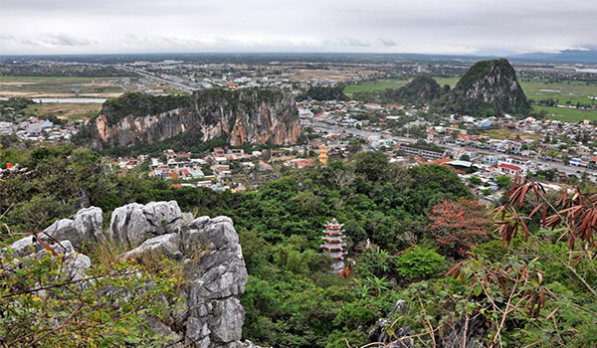

**12:00 PM:** have lunch and check-in Ba Na Hill.

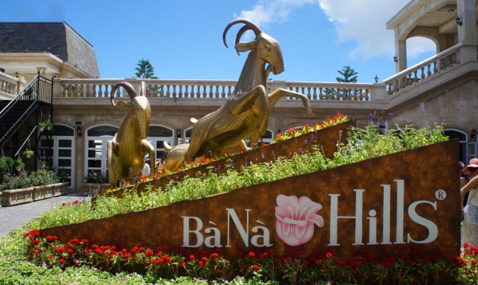

* **Cable car network**

The cable car network of SunWorld Ba Na hills was ranked by CNN as one of the 10 most impressive cable car infrastructure systems worldwide, comprising 5 routes: Suoi Mo – Ba Na, Debay – Morin, Toc Tien Waterfall – L’Indochine, Hoi An – Marseille and Bordeaux – Louvre. Capacity may hit 6,500 passengers/hour and the manufacturer was Doppermayer.

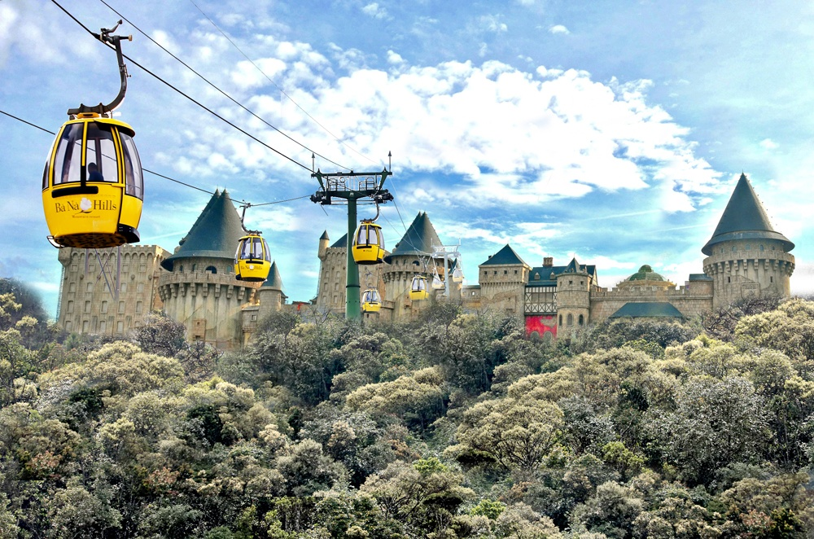

* **Crystal World**

Located at the French Village, the “Crystal World” is operated in a marvelous and first quartz cave inaugurated in Vietnam, which spans 60msqm wide and 3m tall. The cave puts on display 5 tons of scarce natural and unprocessed quartz mined from a mountain cave in Paris (France) at the inception of history. Travelling this quartz cave, visitors are overwhelmed by not only kaleidoscopic quartz stalactites but also a touch of magical works of quartz on our health.

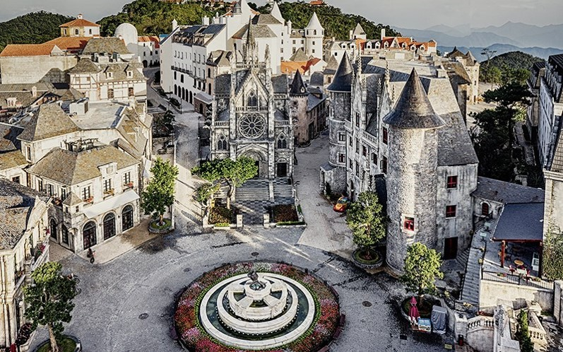

* **Alpine coaster**

Want a bit of speed chills and extreme fun at high latitude? Try out our alpine coaster that sneak inside huge and treacherous twisting tubes. Designed to meet absolutely safety standards and the only double twisted structure in Vietnam, the alpine coaster is a favorite pick of most visitors to SunWorld Ba Na Hills.



* **Fantasy Park**

As a perfect tourist attraction for an entire family, Fantasy Park was commenced and inspired by two iconic novels “Journey to the Center of the Earth” and “Twenty Thousand Leagues Under the Sea” by French writer Jules Verne. The amusement park reserves countless funs and surprises, which of course involve well-tailored games to keep little kids occupied and delighted all day long.

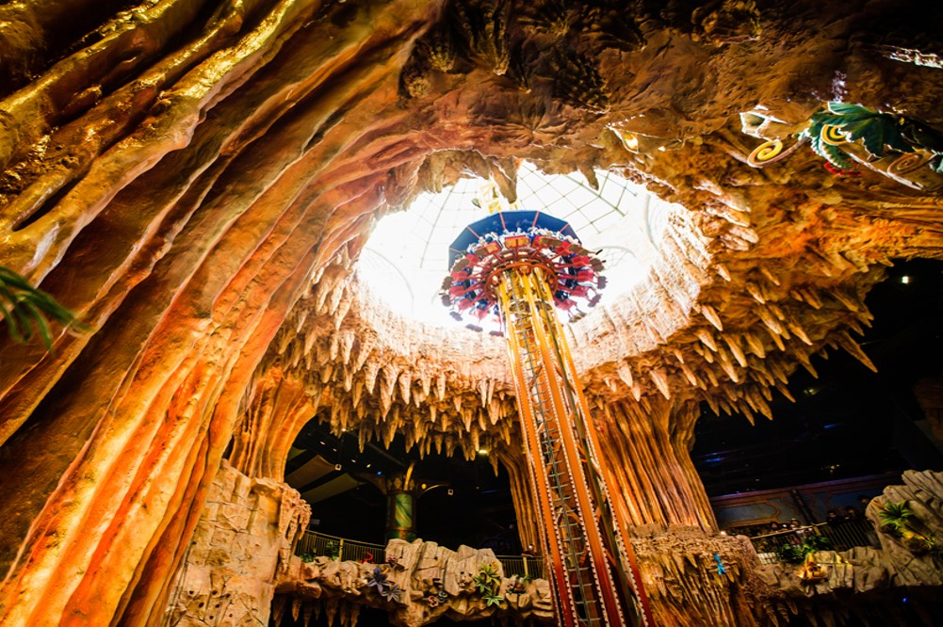

* **Golden Bridge**

A hot destination of Da Nang since August 2018, the Golden Bridge, or Cau Vang in Vietnamese, quickly caught global attention and was listed in TIME's Top Worlds Greatest Places 2018 Lifted by a mossy concrete hand 1,400 meter above sea level, stretching in an arch 148.6 meter long, 3 meter wide, with the handrail plated with gold, this giant brige has attracted many international and local visitors come to admire its amazing architecture as well as the majestic natural surrounding.

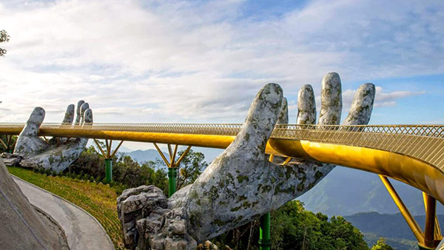

* **French Village**

French Village at Sun World Ba Na Hills is a replica of classical and romantic France in our fantasy, through a string of peculiar architectural clusters: the square, cathedral, town, village and inns… Travelers to the French Village seemto jump the time machine and get carried back to the sophisticated and elegant life in one of the oldest countries of the world.

|  |  |
| --- | --- |
|  |  |

* **Holy Mountain Mother**

Nested in the convergence of the heaven and the earth, yin and yang, Linh Tu Pagoda of the Holy Mountain Mother is dedicated in homage of the Holy Mountain Mother who grants patronage to Ba Na. In addition to climbing the highest point of Danang (1,487m), pilgrims to this pagoda are all drenched in innermost peace and have their worldly greed and fear totally rid.

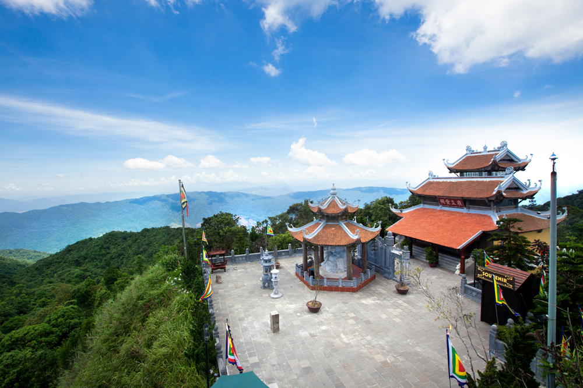

* **Linh Phong Stupa**

Linh Phong Stupa is designed to comprise nine stories that host white marble figurines of Sakyamuni Buddha directing his face to four directions of the mortal world, surrounded by the figurines of the imposing and benevolent Four Great Heavenly Generals in guard. Four bronze bells are hung at four corners on each story are symbolic of the sacred echoes of a religious landmark.

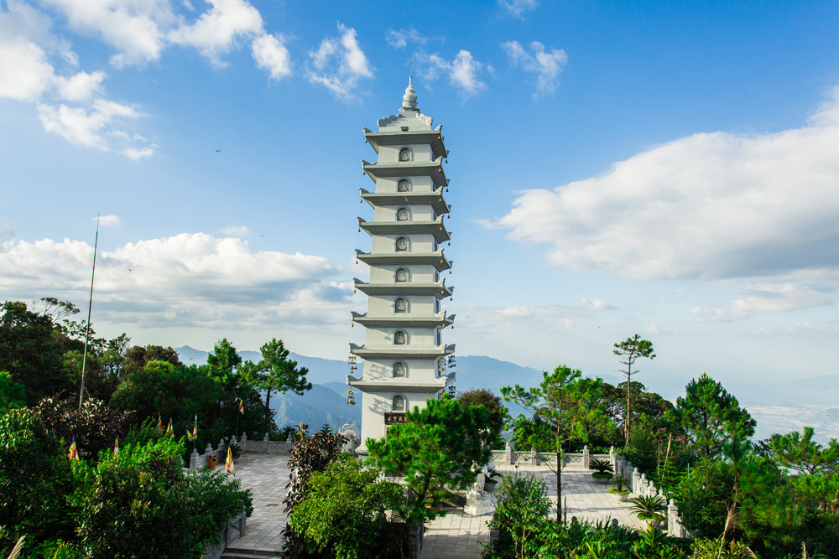

|  |  |
| --- | --- |
|  | Relax – Farewell & Goodbye |

**7:30 – 8:30 AM:** Have breakfast at the hotel.

* When ready and as your scheduled flight allows, check out of your hotel and we’ll take you to the airport in time for your flight.
* End of Tour.

